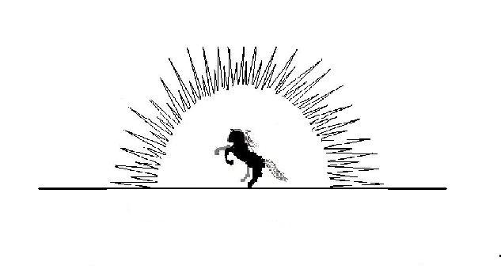
Agape Counseling Services, P.L.L.C.

Formal Complaint Form
If you have any questions regarding this form request assistance from any Agape employee
Fill free to attach additional pages f you need more room

Your Name: __________________________________ Phone Number: __________________
Complaint Information
Date of Incident: ______________ Time: _____________ Location: ____________________
Please describe the incident in detail:

If there are others who have witnessed the incident, please provide their names and phone numbers below:

Do you have any suggestions for resolving the complaint? If so, please explain.

Signature: _________________________________ Date: _________________
If, at any time, you are not satisfied with the agency grievance procedure(s) and you feel you cannot get your concerns addressed through Agape, you may call a number of other agencies. Telephone numbers to reach such an agency include:

- Oklahoma State Board of Licensed Social Workers at 5104 North Francis, Suite E Post Office Box 18817, Oklahoma City, OK 73154-0817. Phone: (405) 946-7230
- Oklahoma State Department of Health Division of Professional Counselor Licensing at 1000 NE 10th Street, Oklahoma City, OK 73117-1299, Phone: (405) 271-6030, Fax: (405) 271-1918
- Oklahoma State Board of Licensed Alcohol and Drug Counselors at 5104 North Francis, Suite F, Post Office Box 54388, Oklahoma City, OK 73154-0817, Phone: (405) 840-8908, Fax: (405) 840-8311
- Oklahoma Health Care Authority at 4545 North Lincoln Blvd., Suite 124, Oklahoma City, OK 73105-3400, Phone: (405) 522-7421, Fax: (405) 530-3246
- Grievance Coordinator, Office of the Advocate Defender, Oklahoma Department of Human Services at P.O. Box 25352, Oklahoma City, OK 7325, Phone: (405) 521-3491
- Grievance Coordinator, Office of The Advocate General, Office of Juvenile Affairs at P.O. Box 268812, Oklahoma City, OK 73126-8812, Phone: (405) 530-2821.
- Oklahoma’s Medicaid Fraud Unit at 405-521-3921.

